INDIGENOUS PROCESSES AND SKILLS IN VERNACULAR ARCHITECTURE OF TANZANIA

CASE PRESENTATION AND FIELD EXPERIENCE

Main objective: Describing Typologies, response and field experience
Specific Objective: Analyzing the process and skills behind
Basic Method-Documenting the Emerging Architectural forms
EXAMPLE
1. House type description; - Name, Plan form and Photograph
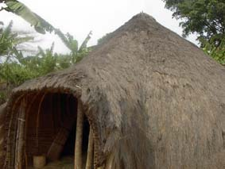
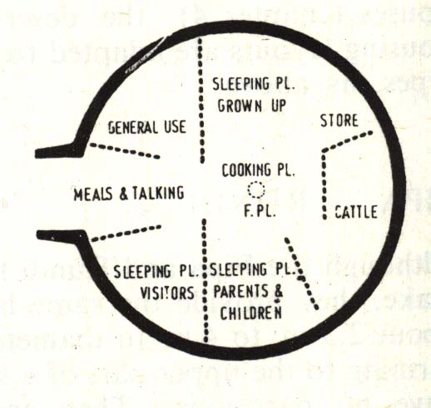
- Mushonge
- Circular plan

.
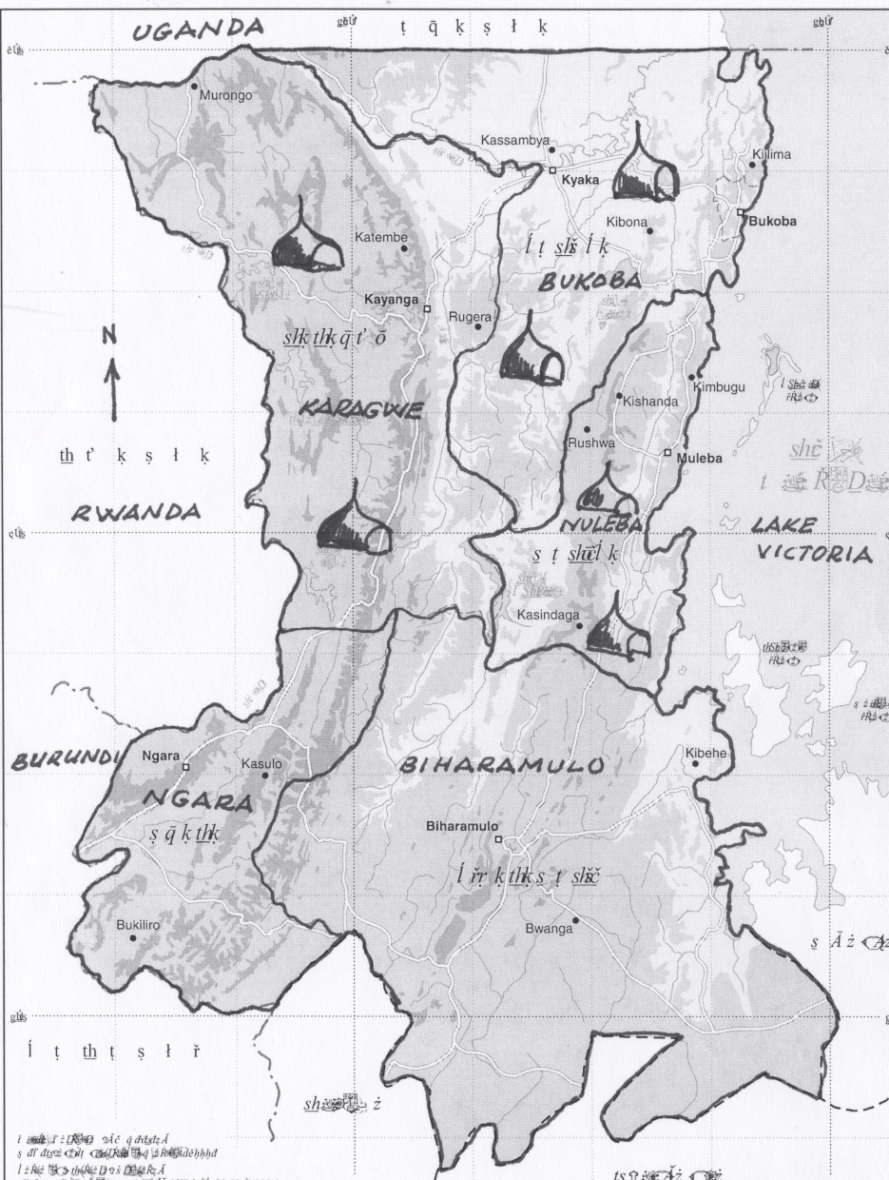
2. Location: - Name of district and a map
- Bukoba
- Karagwe
- Muleba

3. Typical compound layout:-Presenting a sketch or photograph indicating positions of all objects in the compound
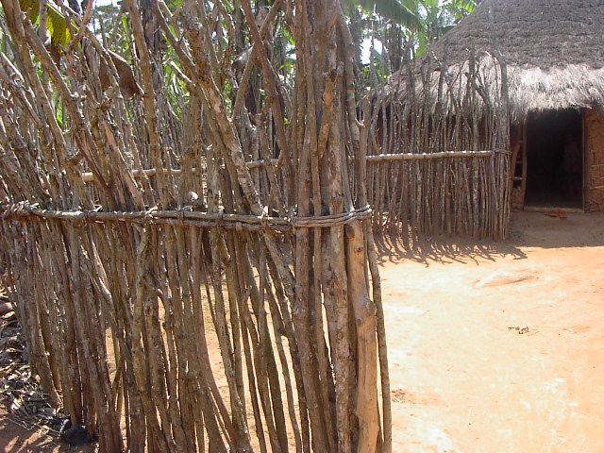
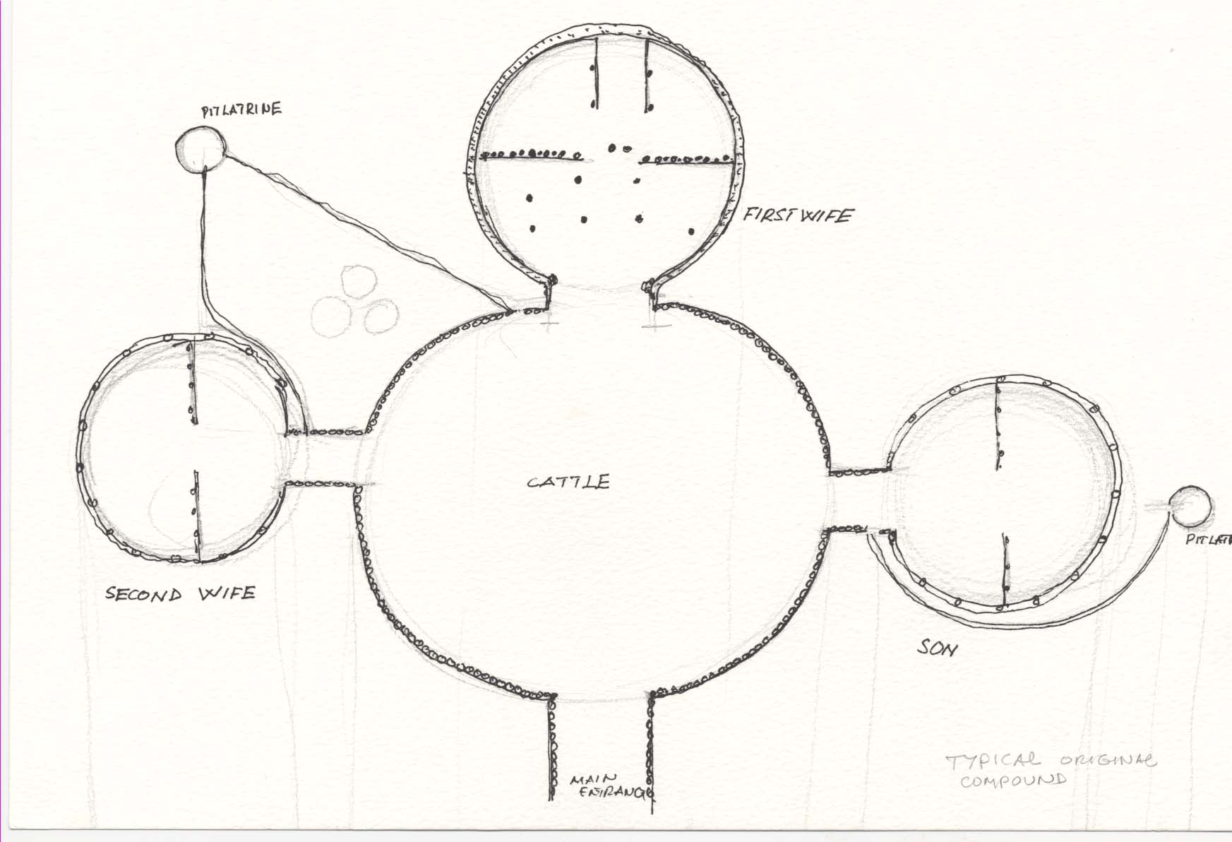

- The main House-Nyaluju- and Cattle Kraal
- House for second wife and house for the married Son
- Detailed floor plan: Indicating names and functional use of spaces
- Entrance space
- Space for meals and talking
- Sleeping space for parents and children
- Sleeping space for grown up
- Cooking and fire space
- Store/cattle/Sleeping space for visitors

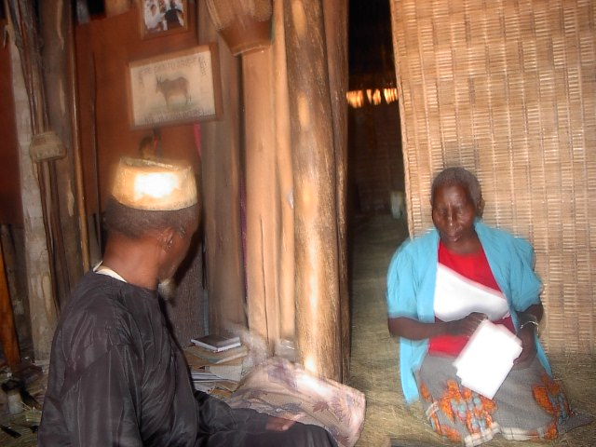
5 The use of Spaces
Spaces in this particular type are divided into two major groups
- Front half as male space
- Back half as female space.
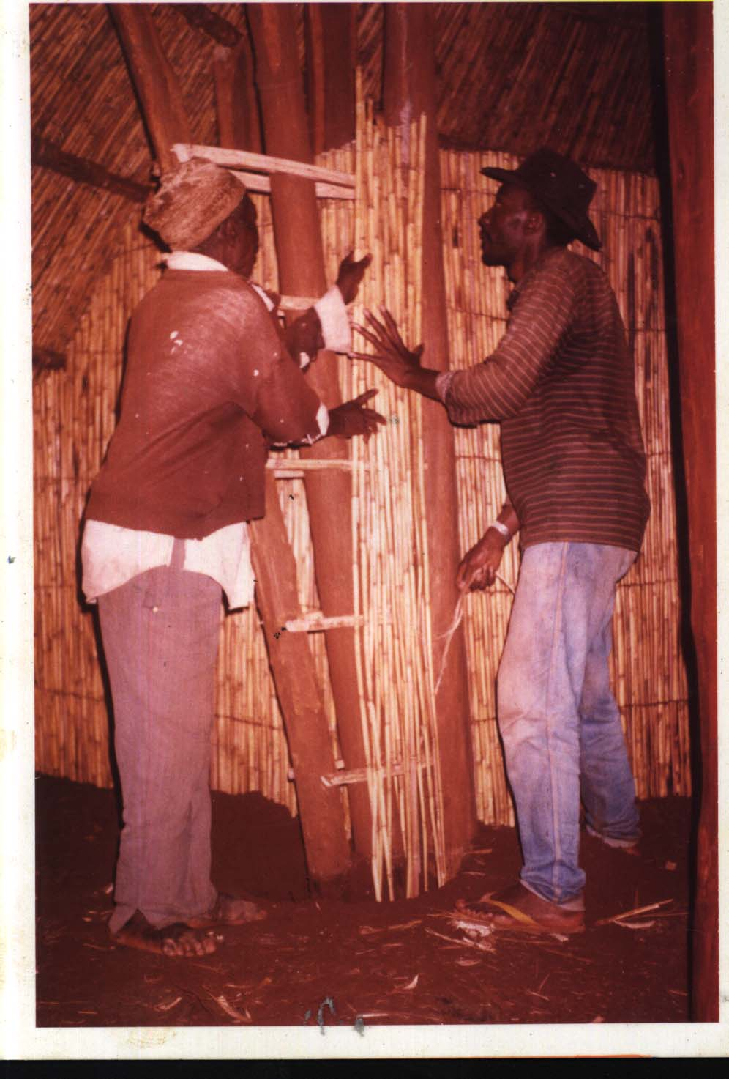
6 Materials: Foundation, walls and roof
- Foundation-Reeds(Imperata Cylindrica)
- Wall-Reeds(Imperata Cylindrica)
- Roof-Reeds ,Poles and Grass
- Floor-Soil and Grass

7. Building processes: Land acquisition, Building permit, Setting and construction

- Land acquisition via customary law on inheritance
- Building permit based on cosmological beliefs and rituals
- Setting –Physical and non physical cosmological fused procedures
8. Materials supply-
- Availability –Abundantly available in nature
- Felling of trees for poles, harvesting of reeds and grass
- Treatment of grass ,reeds and shaping of poles
- Transport is still by head

9. Skills: - In production of different building elements,
- Materials shaping-Shaping of poles, bending of reeds
- Treatment of grass with banana juice and poles with animal fat
- Detailing - weaving of reeds for apex, partitions ,screens ,door and thatch
10. Construction Processes Involved-
Inception to commissioning, including physical and non-physical processes
- Construction of the apex (the ritual process)
- Lifting of the apex (Technical)
- Packing of reeds (Technical)
- The spiral rings (Technical)
- Positioning of poles (Ritual and cosmological process)
- Construction of the entrance canopy (Technical)
- Thatching (Technical)
- Floor finish (Technical)
- Partitioning (Technical)
- Water Isolation at the apex (Technical)
- Surface water isolation (Technical)
FIELD EXPERIENCE
- Response to questionnaires
People are highly respecting traditional spaces, fond of modern building , strict to annual maintenance of their houses, full in control of skills, most of conservative of indigenous processes ,freely exposed to materials, they are self builders, they take modern buildings as buildings out of sand cement blocks and corrugated iron sheets but not functional spaces,
- Attitude towards researchers
People afraid of researchers, some information difficult to extract as people think that researchers are tax people, plain clothes policemen, or refugees with hidden agenda
People were adamant at letting researchers in, most discussion were done from the exterior.
Some could completely avoid the camera, kids could run away
Others demanding payment for responses and photographs
- Expectations of inhabitants
Every body coming from urban center is rich and should assist.

